Financial Management of
Health Care Organizations

Zelman, McCue, Millikan, and Glick

Instructors’ Manual

Instructor’s Manual Table of Contents

- An Orientation to the Book
- Chapters Classified by Academic Discipline
- Organization of the Book
- Alternative Approaches for Organizing Courses Using this Book
- Major Changes in the 2nd Edition
- PowerPoint Slides Containing Both Exhibits and Answers to Questions and Problems
- Excel Files Containing Both Exhibits and Answers to Questions and Problems
- Excel Files with Working Exhibits

- An Orientation to the Book

From the Preface: This book offers an introduction to the most-used tools and techniques of health care financial management. It contains numerous examples from a variety of providers, including health maintenance organizations, home health agencies, nursing units, surgical centers, physician practices, hospitals, departments, and integrated health care systems. The book avoids complicated formulas and uses numerous spreadsheet examples so that the instructor can adapt them to problems in the workplace. For those desiring to go beyond the fundamentals, many chapters have additional information included in appendices. Each chapter begins with a detailed outline and concludes with a detailed summary, followed by a set of key terms and key formulae, questions, and problems. Finally, a number of perspectives are included. Perspectives are intended to provide additional insight into the topic—perspectives from the real world. In some cases these are abstracted from professional journals and in other cases they are statements from practitioners—in their own words.

- Chapters Classified by Academic Discipline

The following chart is intended to help instructors cross-link the chapters with the academic disciplines in which the topics in the text are commonly covered:

Ch. | Chapter Topic | Financial  Accounting | Managerial  Accounting | Finance
1 | Introduction
2 | Healthcare Financial Statements | X
3 | Introduction to Healthcare Accounting | X
4 | Analysis of Healthcare Financial Statements | X |  | X
5 | Introduction to the management of working capital |  |  | X
6 | Time Value of Money |  | X | X
7 | The Investment Decision |  | X | X
8 | Financing the Organization |  |  | X
9 | Using Cost Information for Decision-Making |  | X
10 | Budgeting |  | X
11 | Responsibility Accounting |  | X
12 | Cost-Finding |  | X
13 | Pricing |  | X | X

- Organization of this Book

This book in Chapter 1 begins with an overview of some of the key factors affecting the financial management of health care organizations in today’s environment. Chapters 2, 3, and 4 focus on the financial statements of the organization. Chapter 2 presents an introduction to the financial statements of health care providers. The financial statements are (perhaps along with the budget) the most important financial documents of a health care organization, and the bulk of the chapter is designed to help understand these statements.
Chapter 3 provides an introduction to health care financial accounting. This chapter focuses on the relationship between the actions of health care providers and administrators, and the financial condition of the organization: how the numbers on the financial statements were derived, the distinction between cash and accrual bases of accounting, and the importance of actually defining what is meant by “cost.” Most importantly, this chapter shows how to log financial transactions appropriately, which are used to build the financial statements. By the time students have completed chapters 2 and 3, they will have been introduced to a large proportion of terms used in health care financial management.
Building on Chapters 2 and 3, Chapter 4 shows how to interpret the financial statements of health care organizations. Three approaches to analyzing the statements are presented: horizontal, vertical, and ratio analyses. Great care has been given both to showing how the ratios are computed and how to summarize the results.
Chapter 5 focuses upon the management of working capital: current assets and current liabilities. This chapter emphasizes the importance of cash management and provides many practical techniques for managing the flow of funds into and out of an organization, including managing the billing and collections cycle, and paying off short-term liabilities.
Chapter 6 introduces one of the most important concepts in long-term decision-making: the time value of money. Chapter 7 builds on this concept and relates it to the investment decision by presenting several techniques to analyze investment decisions: the payback method, net present value, and internal rate of return. Examples are given for both not-for-profit and for-profit organizations.
Once an investment decision has been made, Chapter 8, Capital Financing, explains how to finance the decision through debt and equity. Whereas Chapter 5 deals with issues of short-term financing, Chapter 8 focuses on long-term investments, with a particular emphasis on issuing bonds.
Chapters 9 through 12 introduce topics typically covered in managerial accounting. Chapter 9 focuses on the concept of cost and using cost information for short-term decision-making—including fixed cost, variable cost, and breakeven analysis. In addition to covering the key concepts, it offers a set of rules to guide decision-makers in making financial decisions. Chapter 10 explores both the budget and the budget process through a detailed example. Several different budget models are introduced, including program, performance, and zero-based budgeting. The chapter ends with an example of how to prepare each of the five main budgets: statistics budget, revenue budget, expense budget, cash budget, and capital budget. It also includes examples for various types of payors, including flat fee and capitation.
Chapter 11 deals with responsibility accounting. It discusses the different types of responsibility centers and focuses on the performance measurement in general and budget variance analyses in particular. Chapter 12 focuses on methods used by health care providers to determine their costs, primarily focusing on the step-down method and Activity-Based Costing. The book concludes with Chapter 13, Provider Payment Systems. This final chapter -- which was combined with Chapter 12 in the first edition -- focuses upon both the evolution of the payment system in the United States, as well as on the specifics of various approaches to managing care and paying providers.

Alternative Approaches to Organizing a Course Using this Book

The following two alternatives approaches have been used successfully. The first approach is the traditional organization of many health care financial management textbooks. The second approach begins with the foundations, then introduces budgeting and cost-related topics which many students are aware of, and concludes with finance-related topics, which may not be as familiar to many of the students.

Ch. | Chapter Topic | Traditional  Approach | Managerial Accounting  Orientation
1 | Introduction | 1 | 1
2 | Healthcare Financial Statements | 2 | 2
3 | Introduction to Healthcare Accounting | 3 | 3
4 | Analysis of Healthcare Financial Statements | 4 | 9
5 | Introduction to the management of working capital | 5 | 10
6 | Time Value of Money | 6 | 11
7 | The Investment Decision | 7 | 12
8 | Financing the Organization | 8 | 13
9 | Using Cost Information for Decision-Making | 9 | 4
10 | Budgeting | 10 | 5
11 | Responsibility Accounting | 11 | 6
12 | Cost-Finding | 12 | 7
13 | Pricing | 13 | 8

Major Changes in the Second Edition

Global changes: All end of chapter material has been reorganized to include key terms and key formulae, and problems are generally organized from least to most difficult. In most chapters, problems have been paired so that the instructor can use the first problem for an in-class example and assign the second problem. In addition, the exhibits, the perspectives, and the glossary have all been updated.

Chapter 1: The Context of Health Care Financial Management. This chapter has been updated and expanded from the previous edition. It includes many new exhibits showing trends, new perspectives, a set of key terms, and a set of questions.

Chapter 2: Health Care Financial Statements. This chapter has been expanded to include an abbreviated financial statement from an investor-owned organization. In addition, an abbreviated set of notes to financial statements has been added so that the student may see its importance to the overall understanding of the balance sheet and income statement. New perspectives have replaced the perspectives in the first edition. Both the key terms and major equations used throughout the chapter have been summarized at the end for easy reference. The questions at the end of the chapter have been updated and new questions and problems have been added.

Chapter 3: Principles and Practices of Health Care Accounting. The main example around which this chapter is organized has been updated, and less emphasis has been placed on the intricacies of accounting for donations. New perspectives have replaced the perspectives in the first edition. The chapter now includes a listing of key terms, and questions and problems presented in pairs. The number of questions has been expanded, including a number of new transaction problems.

Chapter 4: Financial Statement Analysis. Using data from HCIA-Sachs Inc. (now called Solucient Incorporated), the benchmark ratios were both updated and expanded to include hospitals of various bed sizes. The perspectives in the previous edition were replaced with new ones. In addition, several more questions and ratio analysis problems were added. Several of these are relatively complex, as they require ratio, vertical, and horizontal analyses of the balance sheet and statement of operations (or income statement).

Chapter 5: Working Capital Management. This chapter has been expanded to include a discussion of compliance with laws and regulations for health care organizations regarding HIPAA. The section on the analysis of working capital strategies has been shortened. New perspectives have replaced the perspectives in the previous edition. In addition, new questions and problems have been developed, including some challenging problems related to developing a cash budget.

Chapter 6: The Time Value of Money. This chapter has been updated to include more emphasis on using electronic spreadsheet formulas and less emphasis on using tables to make financial calculations. The content has been expanded to include both payment and rate functions. A number of present and future value problems have been added, mostly in pairs.

Chapter 7: The Investment Decision. Changes were made to clarify how to handle depreciation and interest expenses when converting from accrual-based financial statements to cash flows. In addition, a section has been added to help explain the application of IRR. New questions and problems have been added, with three of the new problems requiring challenging cash flow development for a tax-paying entity. Most problems appear in pairs.

Chapter 8: Financing the Organization. The discussion of equity financing and pooled financing has been expanded and an exhibit has been expanded, and a new exhibit has been developed which provides a listing of key financial ratios for hospital-rated bonds in the year 2000. In addition, a diagram of the bond-rating process was added, and how to amortize a loan was made into an appendix. New exhibits replace the exhibits in the first edition. New problems in the areas of bond valuation, loan amortization, and leasing financing have been added.

Chapter 9: Using Cost Information to Make Special Decisions. The material on the break-even equation has been updated to help the student understand how to apply the basic breakeven equation in cases where direct and indirect costs and/or a desired profit are of concern. The material in the appendix in the first edition -- which discussed a caution pertaining to the use of unit cost -- has been integrated into the chapter. Questions and problems have been listed separately. The problems are mostly in pairs, with the last three being more complex.

Chapter 10: Budgeting. The budget numbers have been updated, primarily to reflect changes in labor rates. The problem section has been modified, including the development of new problems so that most problems now appear as pairs.

Chapter 11: Responsibility Accounting. The problem section has been modified, including the development of new problems, so that most problems now appear as pairs.

Chapter 12: Provider Cost Finding Methods. The section on activity based costing has been greatly expanded, and it now contains an extended example comparing traditional costing to activity-based costing. Provider payment systems, which was a section of this chapter in the previous edition, is now a separate chapter. The problems relating to costing have been expanded, and most problems are now presented as pairs.

Chapter 13: Provider Payment Systems. This is a new chapter containing material that was previously contained in Chapter 12 in the first edition. The material has been greatly reorganized to emphasize the history of payment systems in the United States, with an emphasis on the dynamics among payors, providers, and employers. Some of the methods discussed in the first edition have been moved to an appendix. New questions have been added.

Glossary. The glossary has been completely updated and each term references a related chapter. In addition, all glossary terms are Key Terms, and vice versa, with matching definitions.

- PowerPoint Slides Containing both Exhibits and Answers to Questions and Problems.

This section of the Instructor’s Manual contains PowerPoint files of all exhibits and answers to the end of the chapter problems, organized by chapter.

  - Each chapter’s slides are presented in the order that Exhibits, Questions, and Problems appear in the chapter. All of the slides have been labeled so that by using the “Normal Mode” view, a particular slide can be located instantly and brought up in “Slide Show” mode. (See Appendix I of this document for assistance.) All PowerPoint files are pictures/values only and cannot be modified.

  - Some of the larger exhibits and answers have been broken into several slides so that they may be more easily viewed. Any slide which may still have text too small for a large class to view adequately can always be looked at by “zooming” to a larger magnification in “Slide View.” (See Appendix II of this document for assistance.) In general, each slide has individually been made as large as possible for optimal viewing.

- Excel Files Containing both Exhibits and Answers to Questions and Problems.

This section of the Instructor’s Manual contains Excel Spreadsheets of all exhibits and answers to the end of the chapter problems, organized by chapter.

  - The worksheets in these files contain values only and have a “V” in the name for “Value”, as in “02V Statements.xls”, the values-only Excel file for Chapter 2, Financial Statements

  - All worksheets are in the order of Exhibits, Questions, and then Problems, and all worksheets are in printer-ready format for hand-outs or answer keys.

  - Additionally, any spreadsheet can be zeroed/blanked out and provided to students for them to build their own models with new data and their own formulas.

  - All spreadsheets can be viewed in “Print Preview” mode, and from within, the “Zoom” feature can be used on small text. In general, each spreadsheet has individually been made as large as possible in “Print Preview” for optimal viewing.

- Excel Files with Working Exhibits.

This section of the Instructor’s Manual contains formula-driven Excel Spreadsheets of all exhibits.

  - The selected worksheets in these files are built with formulae and allow the instructor to illustrate the effects of changes in input values which are carried through to the “bottom line.” These files have an “F” in the filename, as in “02F Statements.xls”, and are Exhibits only.

  - If desired, these worksheets also allow the instructor to easily create new problems for homework or exams with minimal effort, as the new answers are automatically created with simple changes to the parameter values at the top.

  - As a suggestion, the instructor can give the students a “values-only” spreadsheet model with a given set of new input parameter values, while the instructor already has the ready-made answer waiting.
Appendix I

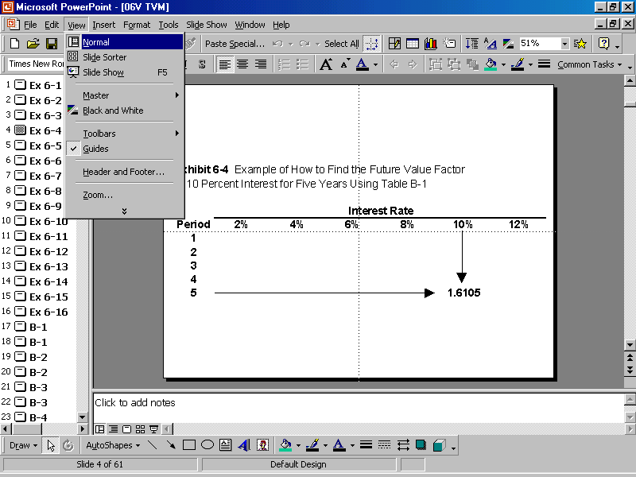
Appendix II

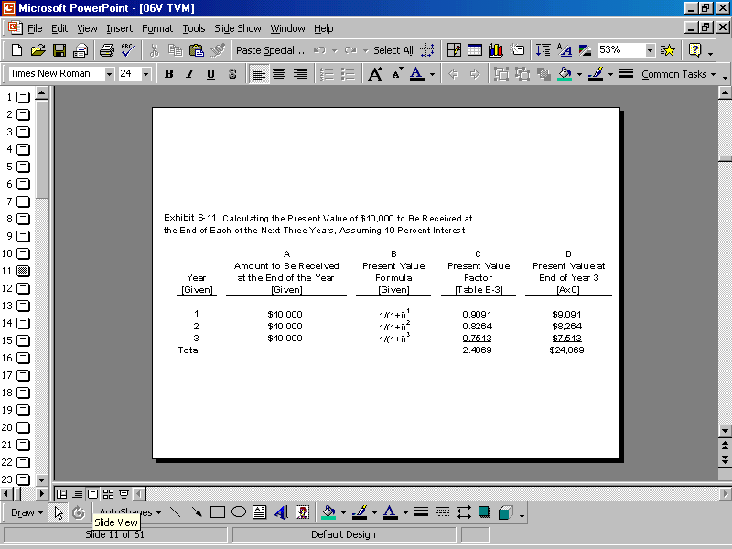

(Continued)
