Chapter Three: Introduction, Research Methods, Culture
First Day Interactive Classroom Learning Activity
Introduction to Psychology Misperception Quiz Classroom Learning Activity
Statistics Classroom Learning Activity
Mini Assignment #1—Develop an experiment
Mini Assignment #2—I am
Mini Assignment #3—Critical Thinking
Mini Assignment #4—Subfields in Psychology
Mini Assignment #5—Approaches to Psychology
Handout #1—Schools of Psychology
Handout #2—A Handy Statistical Reference

PSYCHOLOGY 100

Find someone in this class who meets the following criteria. Only one person per slot, please.
1. After eating a turkey dinner, I’ve felt mellow._______________________
2. I slept 8 hours last night.______________________________________
3. I’ve seen the movie, Fight Club.__________________________________
4. I am colorblind or know someone who is.___________________________
5. A food that I used to like now makes me sick._______________________
The food is ____________________________
6. If given a choice in completing an assignment, I prefer to work in a group rather than by myself.________________________________________
7. I have read, To Kill a Mockingbird._______________________________
8. I have participated in a competitive sport._________________________
9. I have memorized all 50 states._________________________________
10. I like to bungee jump and/or ride fast roller coasters.________________

PSYCHOLOGY QUIZ

1. Schizophrenia is split personality. T F
2. If you need help, you are more likely to get it if there is only one other
person around rather than a crowd. T F
3. Eating turkey will make you more “mellow”. T F
4. Smile!!! I t will make you happy. T F
5. Hearing aides are effective for all types of hearing loss. T F
6. You can learn something without being aware that you learned it. T F
7. The facial expression of emotions is the same in all cultures. T F
8. You only need 5-6 hours of sleep a night to function effectively. T F
9. If a teacher believes that particular students will do better in class,
they usually do perform better. T F
10. Most people eat because they receive hunger signals from their stomach. T F
11. Children will have a higher need to achieve if their parents punish failure. T F
12. In normal development, babies will lose reflexes as they mature. T F
13. Your attachment to your mother as an infant is predictive of your
later romantic relationships. T F
14. Some people are “supertasters” and have more “taste buds” on their tongue. T F
15. When people are colorblind, they can only see shades of brown. T F

You have just graduated from college and have been offered a job with two different small companies. The working conditions and benefits seem to be comparable. However, the president of each company has said only vaguely that your salary "would be comparable to others in the company". In order to give you some basis for comparison, both companies have provided you with the descriptive statistics for salaries throughout the company. Analyze the 2 salary packages and explain how the numbers could have been derived. Which job would you choose and why??”

COMPANY A: COMPANY B:
N=10 N=10
Mean=$33,500 Mean=$28,000
Median=$20,000 Median=$22,500
Mode=$20,000 Mode=$20,000
s.d.=$29,064 s.d.=$12,293
Range=$80,000 Range=$35,000

You believe that students who are lectured to in class, retain more information than students who engage in class discussion. Devise an experiment to test your belief. Be sure to include:
1. Your hypothesis.
2. An operational definition of your variables.
3. An explanation of how you would set-up your experiment. Your explanation should contain the words (in appropriate context) experimental group, control group, dependent variable and independent variable.
NOTE: THIS WHOLE ASSIGNMENT CAN BE ACCOMPLISHED IN ONE OR TWO PARAGRAPHS!!!!

In the spaces on your paper please complete the twenty sentences. This will NOT be collected
so answer the question: "Who am I?" as if giving the answers to yourself, not to someone else. Write your answers in the order in which they occur to you. Do not worry about importance or logic. Go fairly fast.

I am
I am
I am
I am
I am
I am
I am
I am
I am
I am
I am
I am
I am
I am
I am
I am
I am
I am
I am
I am

Applying Critical Thinking to Advertising Claims
What are you being asked to believe in the advertisement claims?

Design an experiment to test this claim:
- What is your hypothesis?
- What is the independent variable (IV)? How is it operationally defined?
- What is your experimental group?
- What is/are your control group(s)?
- What confounding variables might be problematic in your experiment? What will you do to control for these potential confounding variables?

You have decided that you are going to study to become a psychologist!!! Write a letter to a friend describing what type of psychologist you want to be (educational, quantitative, etc.) and what other fields of psychology you considered but rejected. Make sure your letter gives your friend an idea of the diversity of psychology.

Mrs. Jenks, a 4th grade classroom teacher, has asked for an evaluation of Jonathon, a student who acts out in class by hitting other children. As the psychologist in charge of this evaluation, explain the possible causes of Jonathon’s aggression and how you would help Jonathon become less aggressive. Take either a biological, evolutionary, psychodynamic, behavioral, cognitive, or humanistic approach.

SCHOOLS OF PSYCHOLOGY

STRUCTURALISM--Wilhelm Wundt (Germany, 1879)
Other psychologists: Edward Titchener
Goal: Specify the structure of conscious experience.
Method: Experimental introspection.
Application: "Pure science research": spurred development of psychological laboratories.

FUNCTIONALISM--William James (United States, 1890s)
Other psychologists: James McKeen Cattell, E.L. Thorndike, John Dewey
Goal: Studying how the mind worked so that organisms could adapt to their environments.
Method: Naturalistic observation of animal and human behavior.
Application: Child psychology, educational and industrial psychology, study of individual differences

BEHAVIORISM--John B. Watson (United States, 1910s)
Other psychologists: B.F. Skinner
Goal: Study only observable behavior, explain behavior via the conditioned reflex.
Method: Observation of the relationship between the stimulus and response.
Application: Learning theory, environmental emphasis, development of a language to make psychological information more explicit and communicable.

GESTALT--Max Wertheimer (Germany, 1910s)
Other psychologists: Kurt Koffka, Wolfgang Kohler
Goal: Describe organization of mental processes. "The whole is different from the sum of its parts."
Method: Phenomenology (Ex. Phi phenomenon)
Application: Perception, some groundwork for cognitive psychology.

PSYCHOANALYTIC--Sigmund Freud (Germany, 1900s)
Other psychologists: Carl Jung, Alfred Adler
Goal: Explanation of personality and behavior, development of techniques for treating mental illness.
Method: Free association under guidance of analyst; clinical insight.
Application: Development of psychotherapy, emphasis on childhood as important in later personality.

COGNITIVE PSYCHOLOGY--(United States, 1950s)
Goal: Description of physiological processes.
Key concept: Information processing.

HUMANISTIC PSYCHOLOGY--Abraham Maslow (United States, 1960s)
Goal: Mental healthiness of individuals, development of therapeutic techniques.
Key concepts: Self-actualization, free will.

(Permission Houghton Mifflin)
A HANDY STATISTICAL REFERENCE
N = the number of observations, the sample size.
Descriptive statistics are summaries of the data.
Frequency distributions group data into class intervals. Intervals are decided upon by the investigator.
Measures of central tendency represent a central point.
- The mean is simply the arithmetic average.
- The median is the middle score in the distribution.
- The mode is the most frequent score.
Measures of variation are measures of the spread of scores around the average.
- The range tells you the spread between the highest and the lowest score. These are extreme scores, however.
- The standard deviation, s, accounts for every score, not just the extremes, in describing deviation from the mean.
Statistical inferences are based on the following:
- The population is the group total that you are interested in making inferences about; the total number.
- The sample is a random group drawn from the total population you are interested in studying.
- A normal distribution or a normal curve is a bell-shaped curve. For example:
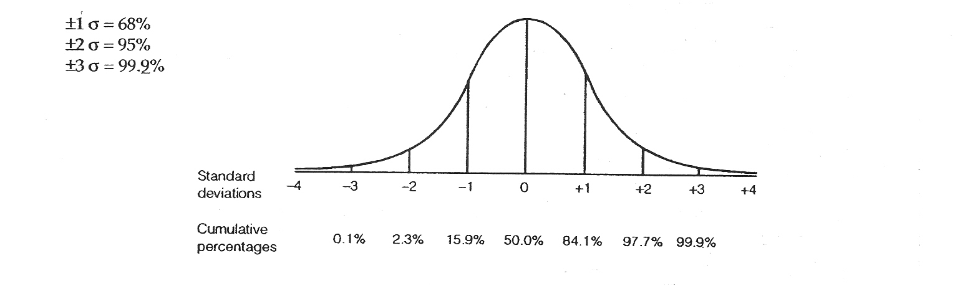
- Statistical significance or significance of a difference represents the probability that the research finding occurred by chance.
Significance: Most social and behavioral sciences have adopted an arbitrary but convenient rule of thumb, the "5% level of significance." If the results are significant at the p < .05, this means that there are only 5 chances in 100 that the findings were chance alone. This statistic can be reported as both the 95% level of significance, and p < .05. Values other than the 95% level may also be chosen. Two of the most common are 90% or p < .10, and 99% or p < .01.
The correlation coefficient is a statistical measure of the direction and the degree of a relationship between 2 variables. The correlation coefficient is denoted as r. The value of r ranges from -1.0 to +1.0. When r = 0, there is no relationship. The closer r gets to 1 or -1, the stronger the relationship. Plus (+) or minus (-) merely indicate the direction of the relationship, not the strength. CORRELATION DOES NOT MEAN CAUSATION.

(Permission Houghton Mifflin)

