Content Store File Import Program

This program allows files to be loaded into the correct portion of the content store. Files can be supplied in any format.
To run the program, run Internet Explorer and enter the URL:

http://www.fulltext/fulltextinet/importbookcontent/import_books_content.htm

This will load the program and display the following options:

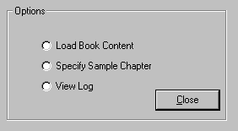

Loading Book Content

To load a file or files containing book content, select the first option and the following will be displayed:

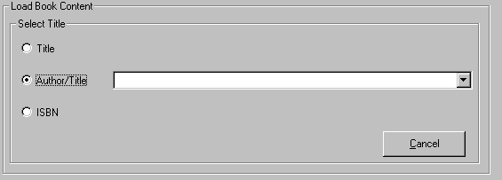
The 3 radio buttons allow titles to be displayed either in Title order, Author/Title order or ISBN order. Select the title of the book (ensuring that it has the correct binding and ISBN) from the dropdown list.
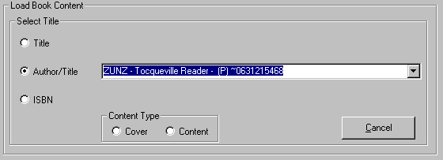
Specify the file content (either Cover or Content) by clicking on the appropriate radio button in the Content Type box. This will cause a button of the appropriate type to be displayed:
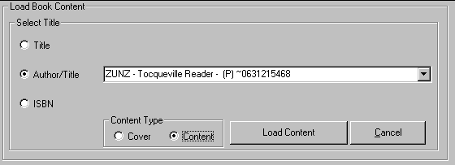
Click the Load Content button and the program will request the location of the file(s) to be loaded:
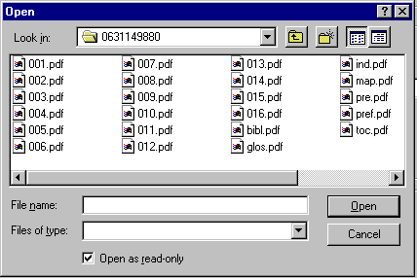
Navigate to the folder that contains the file(s) to be loaded. To load a single file, double click on the filename in the box. To load several files, click on the first file to be loaded, hold down the ctrl key and click on the other files to be loaded (or hold down the Shift key and click on the last file to be loaded). Now click the Open button. The program will then ask whether you wish to delete the target files before installing the new files:
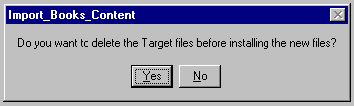
Click the Yes button if you are loading a complete set of files for this title. Click the No button if you are loading a partial set. The program will then load the file(s) and display a completion message:
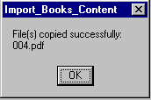

Specifying a Sample Chapter
This works in the same way as loading Book Content (above).
Viewing the Log
Click the view log button and an options frame will be displayed:
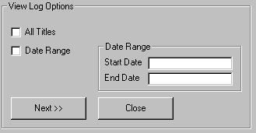
Either click the All Titles checkbox or the Date range checkbox (in which case enter a date range in the form dd-mmm-yyyy. Click the Next button and you will be asked to select the title for which the log entries are required.
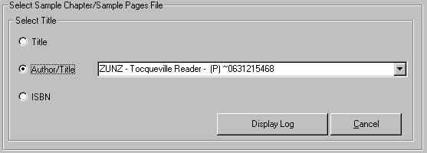
Select a title from the dropdown list and click the Display Log button and the following display will appear:

