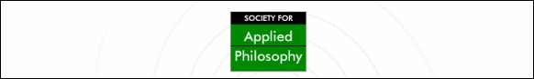

Attend the Society for Applied Philosophy
Events at the APA Eastern Meeting!

Society for Applied Philosophy Session 1:
Sunday, 27 December 2009 Group session I - 6:30-8:30 p.m
Topic: Sovereignty
Chair: Suzanne Uniacke (University of Hull)

Speakers: | Arthur Applbaum (Harvard University) - Legitimacy for Liberals
 | Larry May (Vanderbilt University) - Darfur, Sovereignty, and the Indictment of Al Bashir

Society for Applied Philosophy Session 2:
Tuesday, 29 December 2009 Group Session VIII - 11:15 a.m-1:15 p.m
Topic: Justice and Education
Chair: S. Matthew Liao (New York University) or Tom Sorrell (University of Birmingham)

Speakers: | Harry Brighouse (University of Wisconsin-Madison) - Are There Any Principles of Justice for Education?
 | Michael McPherson (Spencer Foundation) and Matt Smith (Spencer Foundation) (co-authored paper) - Non-Ideal Justice and the Distribution of Higher Education
Commentator: | Randall Curren (University of Rochester)

Society for Applied Philosophy Session 3:
Wednesday, 30 December 2009 Group Session XII - 11:15 a.m-1:15 p.m
Topic: Toleration, Respect, and Recognition
Chair: Suzanne Uniacke (University of Hull)

Speakers: | Brian Leiter (University of Chicago) - Foundation of Religious Liberty: Toleration or Respect?
 | Daniel Weinstock (University of Montreal) - Why Toleration Isn't Enough, and Why Recognition Is Too Much

Society for Applied Philosophy

